**Install OTRS on Centos 8 Linux**

[root@localhost ~]# cd /opt

[root@localhost opt]# sudo curl -O https://otrscommunityedition.com/download/otrs-community-edition-6.0.32.tar.gz



With the archive downloaded, we need to extract it as below with **otrs-*.tar.bz2** as your archive. Ensure you have tar installed

[root@localhost opt]# sudo yum install tar bzip2 -y

[root@localhost opt]# sudo tar -xvf otrs-community-edition-*.tar.gz

Create a symbolic link **/opt/otrs** pointing to the directory of OTRS as below.

[root@localhost opt]# sudo ln -s /opt/otrs-community-edition-6.0.32 /opt/otrs

#2) Install OTRS Dependencies on Rocky Linux 8 | AlmaLinux 8

There are dependencies required for OTRS to run. We will install them from the EPEL repository which we need to add to our system as below

[root@localhost opt]# sudo yum -y install epel-release

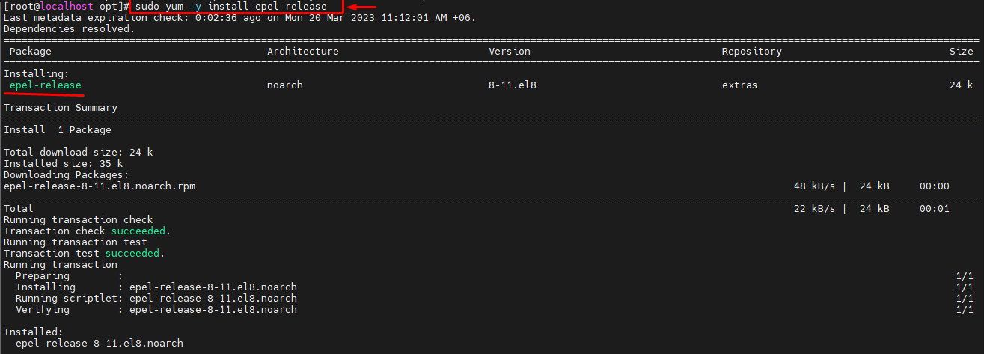

[root@localhost opt]# sudo yum config-manager --set-enabled powertools

[root@localhost opt]# sudo sudo dnf -y makecache

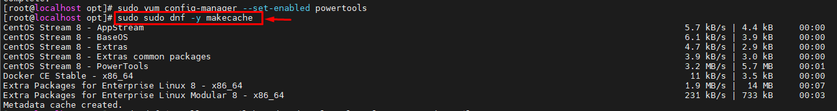

Update the system and install the dependencies as below

[root@localhost opt]# sudo dnf install procmail httpd mod_perl perl perl-core gcc sharutils

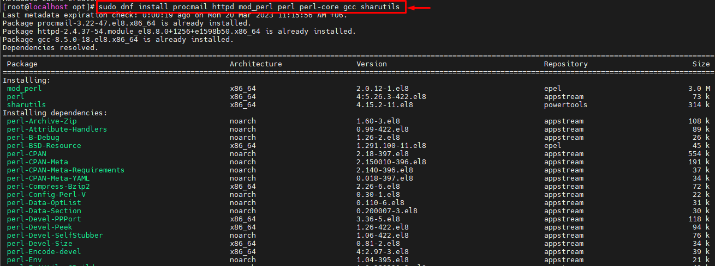

Next, we need to check if all the required modules by OTRS are installed. We need to ensure all the requirements are met. Inside the**/opt/otrs/bin/** is a file which we should execute as below.

[root@localhost opt]# sudo perl /opt/otrs/bin/otrs.CheckModules.pl

Sample Output:

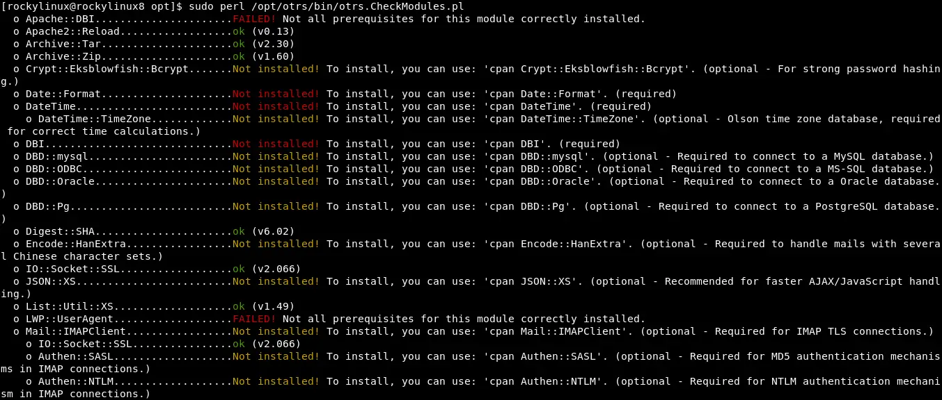

In this guide, we will install everything needed. We will use the PostgreSQL backend so there are packages to install using DNF as below.

[root@localhost opt]# sudo dnf install "perl(Date::Format)" "perl(Crypt::Eksblowfish::Bcrypt)" "perl(DBD::Pg)" "perl(Encode::HanExtra)" "perl(JSON::XS)" "perl(Mail::IMAPClient)" "perl(Authen::NTLM)" "perl(ModPerl::Util)" "perl(Text::CSV_XS)" "perl(YAML::XS)"

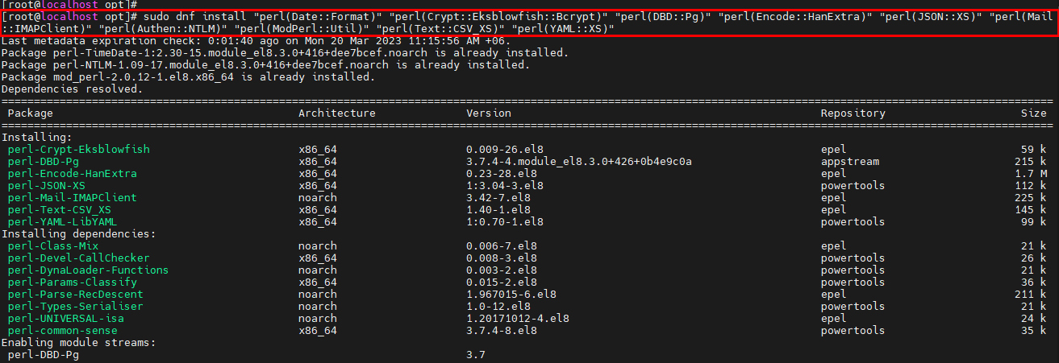

Then the remaining packages are installed using the ***cpan*** command as shown.

[root@localhost opt]# sudo cpan install 'DateTime'

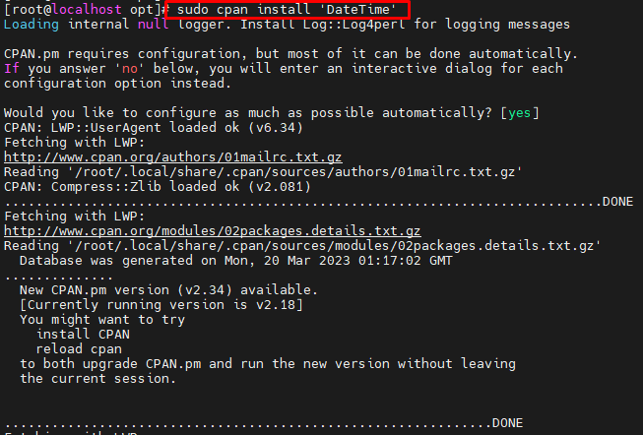

[root@localhost opt]# sudo cpan install Moo Net::LDAP Template Template::Stash::XS XML::LibXML XML::LibXSLT

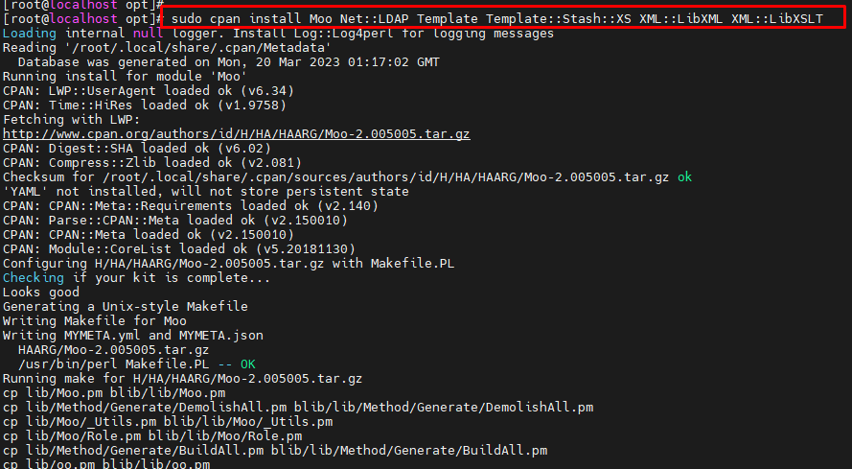

Sample Output:

CPAN.pm requires configuration, but most of it can be done automatically. If you answer 'no' below, you will enter an interactive dialog for each configuration option instead.

Would you like to configure as much as possible automatically? [yes] **yes**

**Set SELinux in permissive mode.**

sudo setenforce 0

sudo sed -i 's/^SELINUX=.*/SELINUX=permissive/g' /etc/selinux/config

**#3) Create an OTRS user and Permissions**

We need a user to own the /opt/otrs directory. So we will create the OTRS user as below.

[root@localhost opt]# sudo useradd otrs

Add the created user to the apache group as below

[root@localhost opt]# sudo usermod -G apache otrs

The membership of the user will appear as shown.

[root@localhost opt]# id otrs

uid=1001(otrs) gid=1001(otrs) groups=1001(otrs),48(apache)

Now copy the configurations file***/opt/otrs/Kernel/Config.pm.dist*** to **/opt/otrs/Kernel/** to act as the configuration for the application.

[root@localhost opt]# sudo cp /opt/otrs/Kernel/Config.pm.dist /opt/otrs/Kernel/Config.pm

Copy the application’s configuration to the apache web server.

[root@localhost opt]#

sudo cp /opt/otrs/scripts/apache2-httpd.include.conf /etc/httpd/conf.d/otrs.conf

Unlink the Apache default page.

[root@localhost]#

sudo mv /etc/httpd/conf.d/welcome.conf /etc/httpd/conf.d/welcome.conf_backup

Check if the modules required are loaded with the below command:

[root@localhost opt]# apachectl -M | grep -E 'version|deflate|filter|headers'

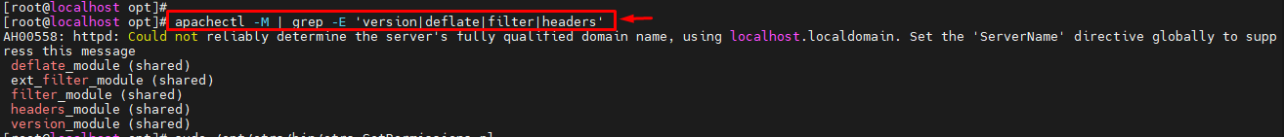

Set permissions on the OTRS file as below. ( please tun the command as root)

[root@localhost opt]# sudo /opt/otrs/bin/otrs.SetPermissions.pl



Initialize the PostgreSQL database.

[root@localhost opt]# sudo postgresql-setup –initdb

[root@localhost opt]# sudo systemctl start httpd

[root@localhost opt]# sudo systemctl enable httpd

Now start and enable Apache web server as below

Allow port 80 and 443 through the firewall

[root@localhost opt]# sudo firewall-cmd --permanent --add-service=http

success

[root@localhost opt]# sudo firewall-cmd --permanent --add-service=https

success

[root@localhost opt]# sudo firewall-cmd --reload

**#4) Install and Configure MariaDB Database.**

Install MariaDB on Rocky Linux 8 using the command.

[root@localhost opt]# yum install @mariadb -y

[root@localhost opt]# systemctl enable mariadb.service

[root@localhost opt]# systemctl start mariadb.service

[root@localhost opt]# systemctl status mariadb.service

[root@localhost opt]# firewall-cmd --permanent --add-service=mysql

[root@localhost opt]# firewall-cmd –reload

Secure database server installation:

[root@localhost opt]# mysql_secure_installation

Create a database for OTRS. By logging in to the MariaDB shell.

[root@localhost opt]# mysql -u root –p

Enter password: 123

MariaDB [(none)]> CREATE DATABASE otrs_db1 character set UTF8 collate utf8_bin;

Query OK, 1 row affected (0.003 sec)

MariaDB [(none)]> GRANT ALL PRIVILEGES ON otrs_db1.* TO 'otrs1'@'localhost' IDENTIFIED BY 'password';

Query OK, 0 rows affected (0.009 sec)

MariaDB [(none)]> FLUSH PRIVILEGES;

Query OK, 0 rows affected (0.004 sec)

MariaDB [(none)]> exit

Change the default MySQL settings.

[root@localhost ~]# vim /etc/my.cnf

Edit the file to match this.

[mysqld]

max_allowed_packet=64M

query_cache_size=36M

innodb_log_file_size=256M

character-set-server=utf8

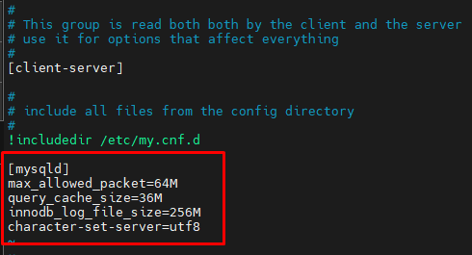

Restart MariaDB to apply these changes.

[root@localhost opt]# sudo systemctl restart mariadb

Edit the configuration below at **/opt/otrs/Kernel** as shown.

[root@localhost opt]# sudo vim /opt/otrs/Kernel/Config.pm

Edit your file to match the below content.

# The database name

$Self->{Database} = 'otrs_db1';

# The database user

$Self->{DatabaseUser} = 'otrs1';

# The password of database user. You also can use bin/otrs.Console.pl Maint::Database::PasswordCrypt

# for crypted passwords

$Self->{DatabasePw} = 'password';

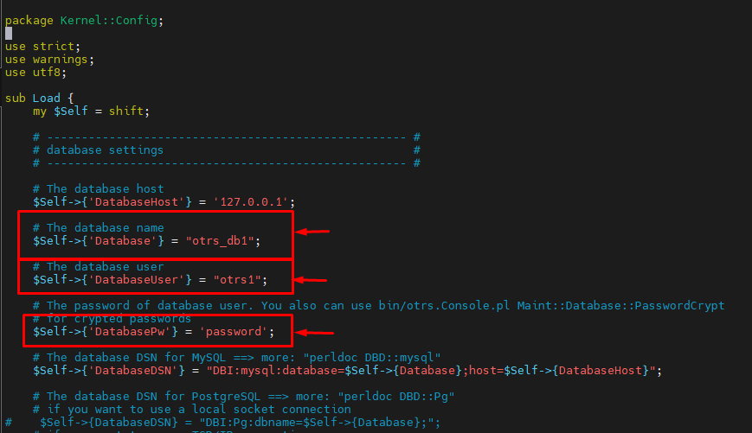

Then enable MySQL support by editing the below file.

[root@localhost opt]# vim /opt/otrs/scripts/apache2-perl-startup.pl

Edit your file as below.

# enable this if you use mysql

use DBD::mysql ();

use Kernel::System::DB::mysql;



Restart Apache for the changes made to apply.

[root@localhost opt]# sudo systemctl restart httpd

URL [http://HOST_NAME/otrs/installer.pl](https://host_name/otrs/installer.pl) or [http://IP_Address/otrs/installer.pl.](https://ip_address/otrs/installer.pl)

**Step 4: (Optional) Secure OTRS on Rocky Linux 8 with Let’s Encrypt.**

It is possible to access and install OTRS on Rocky Linux 8 without SSL. However, this is done to allow you to access the web via HTTPS. For this to happen, you should install SSL certificates or any other certificates on your system.

We will first install Certbot on Rocky Linux 8.

sudo dnf install certbot python3-certbot-apache -y

Dependency Tree:

Transaction Summary

================================================================================

Install 22 Packages

Then add a VirtualHost to your conf file.

sudo vi /etc/httpd/conf.d/otrs.conf

At the top of the conf file, add the below lines replacing your **Domain Name** appropriately.

<VirtualHost *:80>

ServerName **Enter your domain name**

DocumentRoot /opt/otrs/bin/cgi-bin

<Directory /opt/otrs/bin/cgi-bin/>

Options FollowSymLinks

AllowOverride None

DirectoryIndex /otrs/index.pl

</Directory>

</VirtualHost>

Then install the SSL certificate for Apache on Rocky Linux as below.

sudo certbot -apache

Proceed to an interactive prompt and install the certificate.

Saving debug log to /var/log/letsencrypt/letsencrypt.log

Plugins selected: Authenticator nginx, Installer nginx

Enter email address (used for urgent renewal and security notices)

(Enter 'c' to cancel): **Enter a valid Email address here**

- - - - - - - - - - - - - - - - - - - - - - - - - - - - - - - - - - - - - - - -

Please read the Terms of Service at

https://letsencrypt.org/documents/LE-SA-v1.2-November-15-2017.pdf. You must

agree in order to register with the ACME server. Do you agree?

- - - - - - - - - - - - - - - - - - - - - - - - - - - - - - - - - - - - - - - -

(Y)es/(N)o: **y**

- - - - - - - - - - - - - - - - - - - - - - - - - - - - - - - - - - - - - - - -

Would you be willing, once your first certificate is successfully issued, to share your email address with the Electronic Frontier Foundation, a founding partner of the Let's Encrypt project and the non-profit organization that develops Certbot? We'd like to send you email about our work encrypting the web,EFF news, campaigns, and ways to support digital freedom.

- - - - - - - - - - - - - - - - - - - - - - - - - - - - - - - - - - - - - - - -

(Y)es/(N)o: **Y**

Account registered.

Which names would you like to activate HTTPS for?

- - - - - - - - - - - - - - - - - - - - - - - - - - - - - - - - - - - - - - - -

1: otrs.techwizpro.com

- - - - - - - - - - - - - - - - - - - - - - - - - - - - - - - - - - - - - - - -

Select the appropriate numbers separated by commas and/or spaces, or leave input

blank to select all options shown (Enter 'c' to cancel): 1

Requesting a certificate for otrs.techwizpro.com

Successfully received certificate.

Certificate is saved at: /etc/letsencrypt/live/otrs.techwizpro.com/fullchain.pem

Key is saved at: /etc/letsencrypt/live/otrs.techwizpro.com/privkey.pem

This certificate expires on 2021-12-08.

These files will be updated when the certificate renews.

With all done, you will see a congratulatory message.

Deploying certificate

Successfully deployed certificate for otrs.techwizpro.com to /etc/httpd/conf.d/otrs-le-ssl.conf

Congratulations! You have successfully enabled HTTPS on https://otrs.techwizpro.com

NEXT STEPS:

- The certificate will need to be renewed before it expires. Certbot can automatically renew the certificate in the background, but you may need to take steps to enable that functionality. See https://certbot.org/renewal-setup for instructions.

- - - - - - - - - - - - - - - - - - - - - - - - - - - - - - - - - - - - - - - -

If you like Certbot, please consider supporting our work by:

* Donating to ISRG / Let's Encrypt: https://letsencrypt.org/donate

* Donating to EFF: https://eff.org/donate-le

- - - - - - - - - - - - - - - - - - - - - - - - - - - - - - - - - - - - - - - -

Restart Apache:

**sudo systemctl restart httpd**

Step 5: Install OTRS on Rocky Linux 8

We will do the OTRS installation on Rocky Linux 8 using the web installer. We will access the Web UI using the URL [https://HOST_NAME/otrs/installer.pl](https://host_name/otrs/installer.pl)

skip

While on this page, click next to continue with the installation. Read the Licence Terms and accept them to proceed.

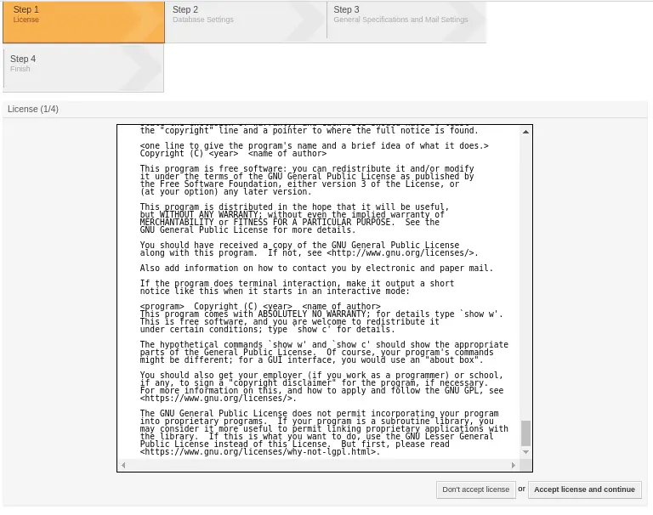

Choose the type of database. In this Guide, I will use MySQL and also check the box “**use an existing database for OTRS**”

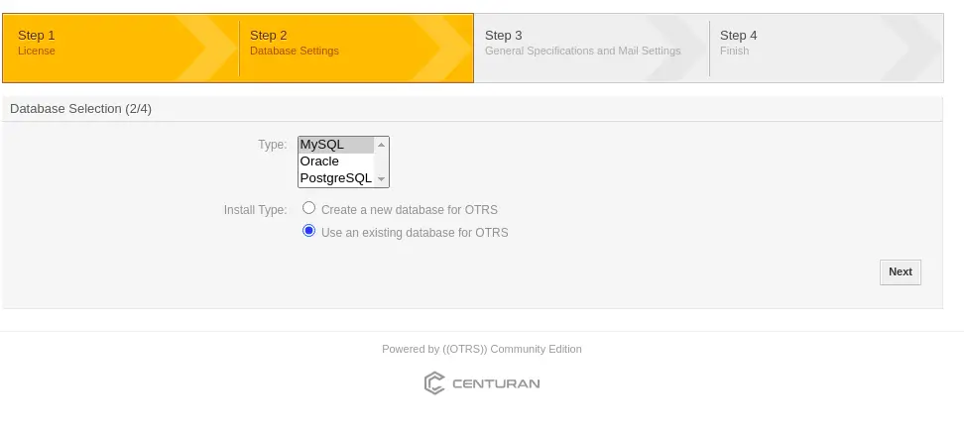

Here, enter the user, password, and database name created in MariaDB. When done, test by clicking **check database settings**

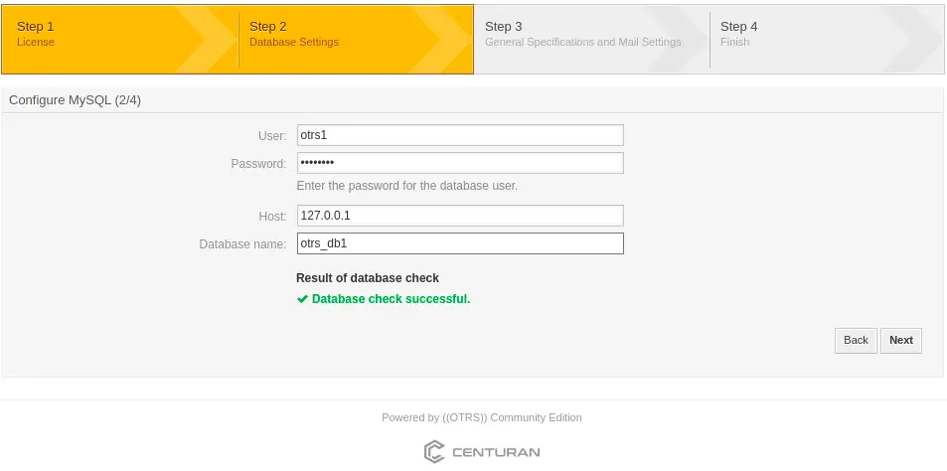

If it connects successfully, you will see the **database check is successful.** Click next and the database schema will be created.

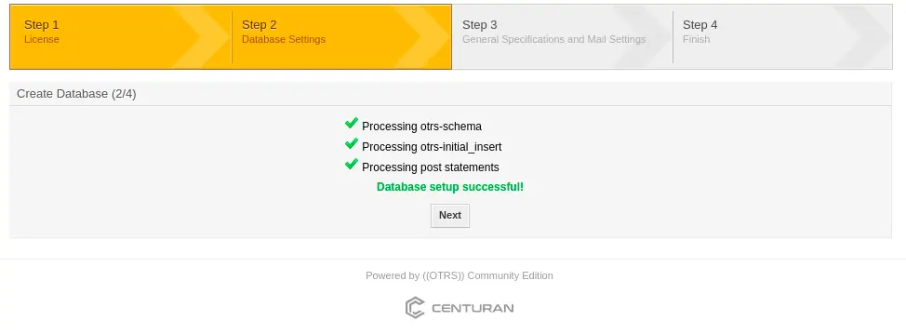

On this page, provide general details such as the address of the admin and language. In case you don’t have a public DNS server set t **CheckMXRecord** to “**no**”

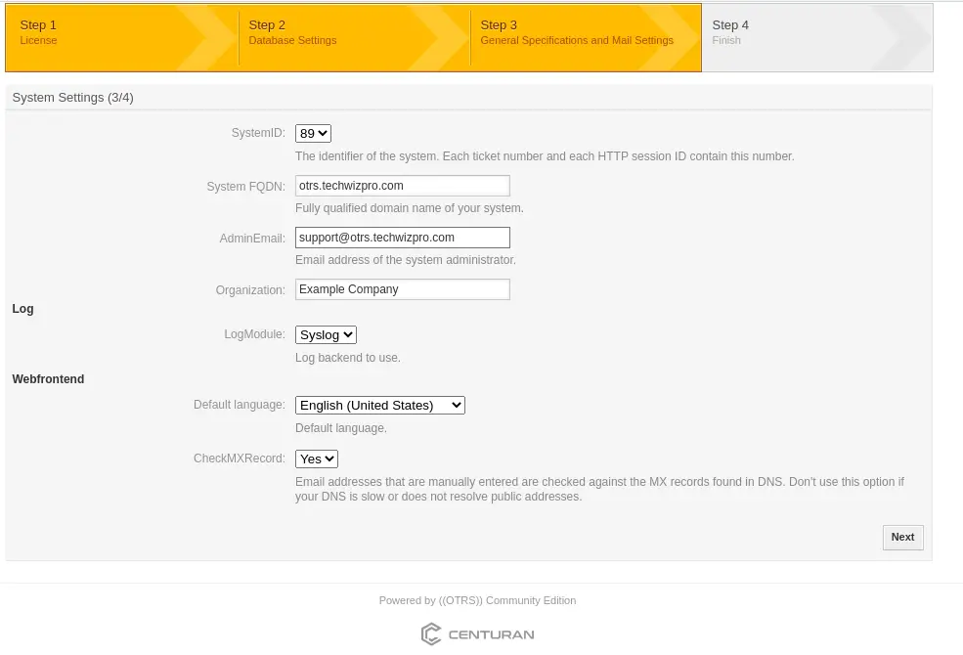

In this step, you are required to provide an email address if you want to send email addresses with OTRS, otherwise, you can **skip** this and finish your installation.

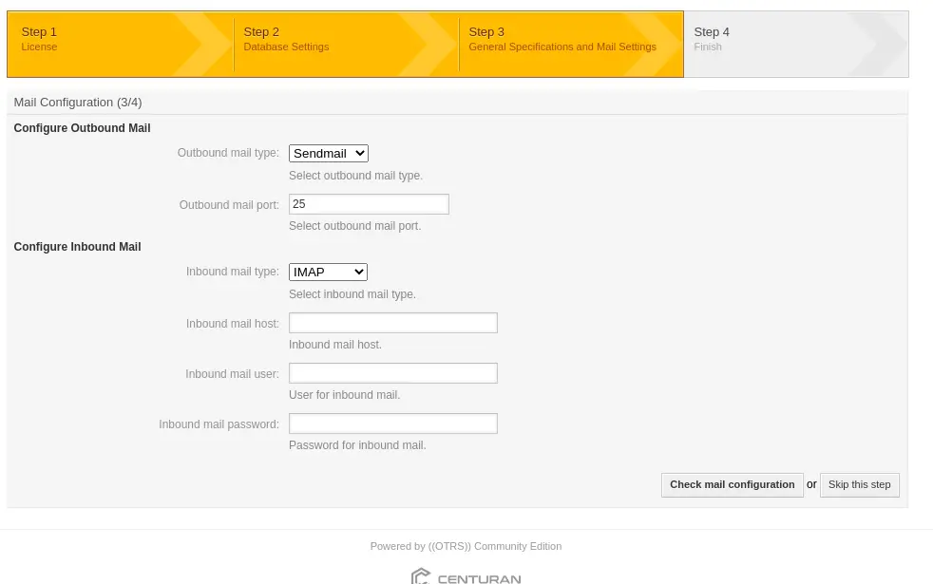

With the installation complete, you will be given a username, a password as well as the link to redirect you to the login page

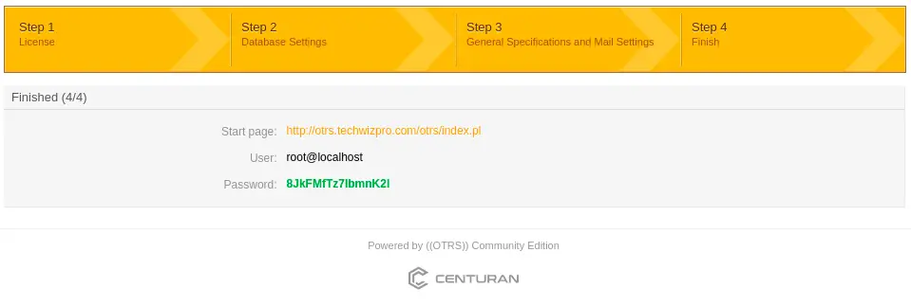

Login with the credentials provided.

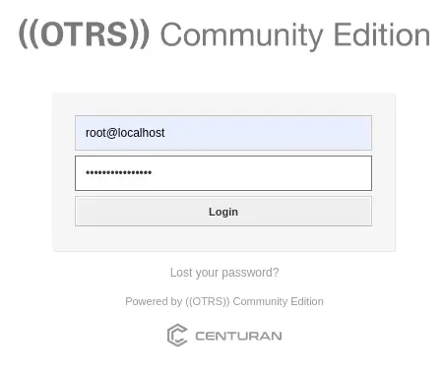

This is the OTRS Web UI.

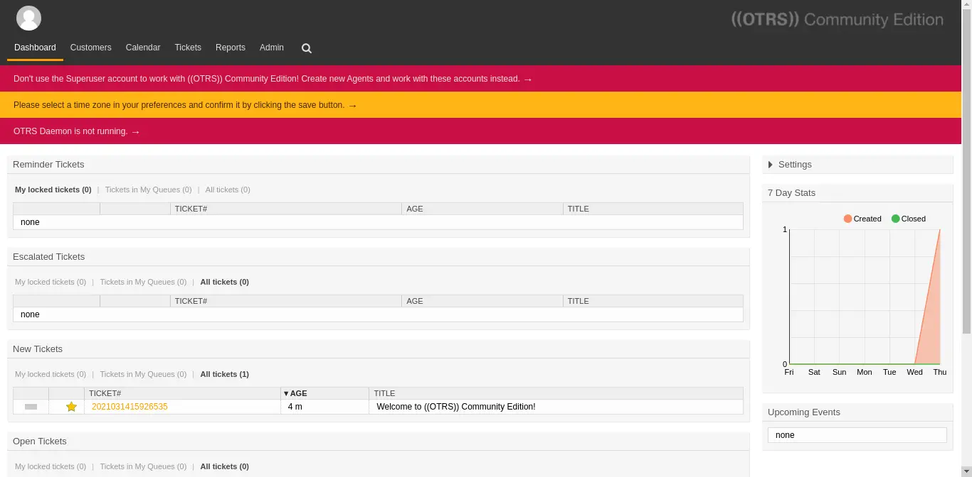

Now we are set to begin filling it with content and customize it according to what we need. The first ticket is already awaiting, this is definitely a welcome message and other useful links

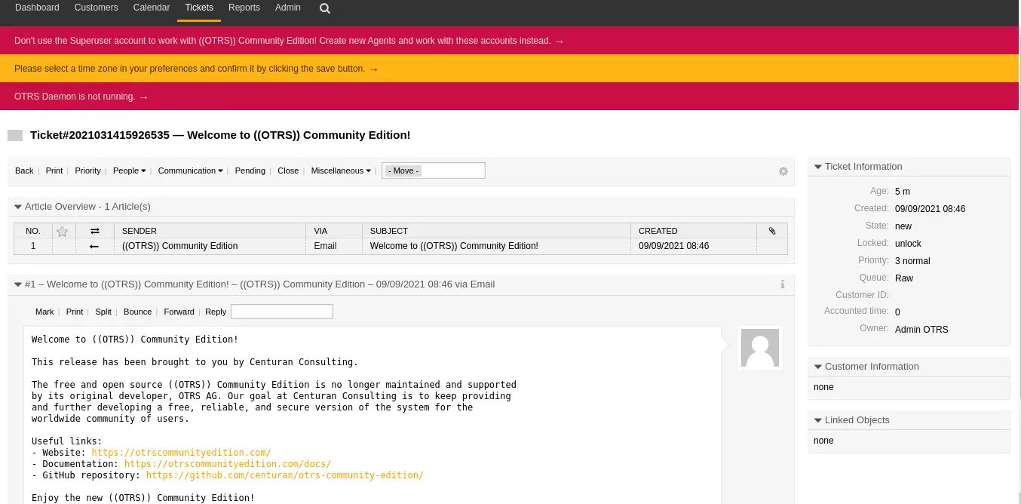

To do away with the message “**OTRS daemon not running**” start the OTRS daemon.

[root@localhost opt]# su otrs

[otrs@localhost opt]$ /opt/otrs/bin/otrs.Daemon.pl stop

Manage the OTRS daemon process.

Daemon stopped

[otrs@localhost opt]$ /opt/otrs/bin/otrs.Daemon.pl start

Manage the OTRS daemon process.

Daemon started

[otrs@localhost opt]$ /opt/otrs/bin/Cron.sh start

(using /opt/otrs) done

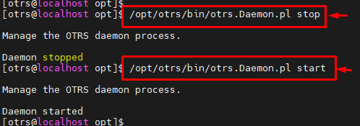

Sorce Link : <https://techviewleo.com/how-to-install-otrs-rocky-linux-almalinux/>